**Project Title: Bank Customer Churn Prediction Using SQL**

**Introduction**

The objective of this project is to analyze customer data to predict churn rates and identify key factors influencing customer retention in the banking sector. By leveraging SQL for data manipulation and analysis, the project aims to derive actionable insights that can inform marketing strategies and improve customer retention.

**Business Scenario**

The banking industry faces significant challenges in retaining customers amidst increasing competition. Understanding the characteristics of customers who churn versus those who remain is critical for developing targeted retention strategies. This document outlines the key questions, KPIs, findings, and proposed marketing strategies based on the analysis of customer data.

**Key Questions**

1. **Customer Segmentation**: What are the characteristics of customers who churn versus those who remain?
2. **Churn Prediction**: Can we predict which customers are likely to churn based on their attributes?
3. **Product Usage**: How does the number of products a customer has relate to their likelihood of churning?
4. **Demographic Analysis**: What demographic factors (age, gender, country) are associated with higher churn rates?
5. **Balance Impact**: Does a higher account balance correlate with lower churn rates?
6. **Credit Score Influence**: How does a customer's credit score affect their likelihood of remaining an active member?
7. **Tenure Analysis**: Is there a relationship between the length of time a customer has been with the bank and their likelihood to churn?
8. **Salary Insights**: How does estimated salary influence customer retention and product usage?
9. **Active Membership Trends**: What percentage of customers are active members, and how does this relate to churn?
10. **Country Comparison**: Which country has the highest churn rate and what factors contribute to this?
11. **Gender Differences**: Are there significant differences in churn rates between male and female customers?
12. **Product Effectiveness**: Which products are associated with higher retention rates among customers?
13. **Churn Rate Over Time**: How has the churn rate changed over different periods (e.g., by tenure)?
14. **Customer Value Assessment**: What is the average balance of customers who have churned compared to those who have not?
15. **Marketing Strategies**: What targeted marketing strategies could be developed based on customer characteristics to reduce churn?

**Key Performance Indicators (KPIs)**

* **Total Unique Customers**: 10,000
* **Average Balance**: $76,485.88
* **Average Estimated Salary**: $100,000
* **Credit Card Holder Percentage**: 70.55%
* **Average Churn Rate:** 20.37%

**Characteristics of Churned vs. Retained Customers**

* **Age and Balance**: Churned customers have an average age of 44 years and a higher average balance of $91,108, compared to retained customers, who average 37 years in age and have a balance of $73,745. This suggests that older customers with larger balances may feel dissatisfied or have unmet needs, indicating a potential area for improvement in customer service and engagement strategies.

**Churn Prediction Insights**

* **Product Usage**: Customers holding two products show a significantly lower churn rate (0.0758), while those with four products experience a high churn rate (1.00). This indicates that offering a variety of products can enhance customer retention.
* **Demographics**: Female customers exhibit a higher churn rate (0.25) compared to males (0.16), with the average age for females being slightly higher (40.15). Targeting retention strategies towards middle-aged female customers may be beneficial.

**Product Usage and Effectiveness**

* The data suggests that having multiple products correlates with lower churn rates, highlighting the importance for banks to promote bundled services to foster customer loyalty.

**Demographic Analysis**

* **Age**: Customers aged 40-50 are the most likely to churn. Retention efforts should focus on this demographic.
* **Country Comparison**: In Germany, female customers have a notable churn rate of 0.37% despite having an average balance of $119,145 and salary of $102,446, suggesting that financial stability does not guarantee loyalty.

**Balance Impact**

* Interestingly, customers with low balances exhibit lower churn rates (0.19) compared to those with high balances (0.23). This counterintuitive finding may require further investigation into customer satisfaction levels and service quality.

**Credit Score Influence**

* Customers with credit scores below 750 have a 51.28% likelihood of remaining active members, while those above 750 have a slightly higher retention rate at 52%. This underscores the significance of financial health in retention strategies.

**Tenure Analysis**

* Churn rates are highest among new customers (0 months) at 0.2300 but decrease to around 0.1722 by the seventh year, indicating that customer loyalty tends to increase with tenure. Early engagement strategies are crucial.

**Salary Insights**

* High-income individuals show a retention rate of 20%, slightly above medium (19.87%) and low-income (19.93%) groups, suggesting that while financial capability influences loyalty, it is not the sole factor.

**Active Membership Trends**

* Active members have a lower churn rate (0.14%) compared to non-active members (0.26%), reinforcing the need for banks to encourage active engagement through personalized services.

Recommendations

1. **Targeted Marketing Strategies**: Focus on middle-aged females in France and Spain and young males in Germany for tailored marketing campaigns.
2. **Product Bundling Promotions**: Encourage customers to hold multiple products by offering incentives or discounts for bundled services.
3. **Enhanced Customer Engagement**: Develop personalized engagement strategies for customers aged 40-50 to address their specific needs and concerns.
4. **Leverage Data Analytics**: Utilize demographic, behavioral, and psychographic data to create more nuanced customer segments for targeted marketing efforts.
5. **Early Customer Relationship Building**: Implement proactive engagement strategies for new customers to foster loyalty from the outset.
6. **Monitor Satisfaction Levels**: Conduct regular surveys and feedback sessions to understand customer satisfaction across different segments, particularly focusing on older customers with higher balances.

**Conclusion**

This document serves as a comprehensive overview for analyzing customer behavior related to churn within the banking sector using SQL-based insights. The findings will guide strategic decisions aimed at improving customer retention and minimizing attrition through targeted marketing efforts and enhanced customer engagement initiatives.

Next Steps

1. Validate findings through further data analysis.
2. Develop predictive models using SQL queries for real-time insights.
3. Implement marketing strategies based on identified customer segments.

This structured approach ensures that all aspects of customer behavior are considered in developing effective retention strategies while leveraging data-driven insights for continuous improvement in service delivery within the banking industry.

**SQL QUERIES USED TO PROVIDE INSIGHTS ON KEY QUESTIONS:**

**Database Creation**

**Create Database:**

CREATE DATABASE BANK_DB;

USE BANK_DB;

**Create Table:**

CREATE TABLE CUST_DT (

CUSTOMER_ID INT,

CREDIT_SCORE INT,

COUNTRY VARCHAR(50),

GENDER VARCHAR(7),

AGE INT,

TENURE INT,

BALANCE FLOAT,

PRODUCTS_NUMBER INT,

CREDIT_CARD INT,

ACTIVE_MEMBER INT,

ESTIMATED_SALARY DECIMAL(8 , 6 ),

CHURN INT

);

**Check for NULL Values in Columns:**

SELECT

CUSTOMER_ID IS NULL,

CREDIT_SCORE IS NULL,

COUNTRY IS NULL,

GENDER IS NULL,

AGE IS NULL,

TENURE IS NULL,

BALANCE IS NULL,

PRODUCTS_NUMBER IS NULL,

CREDIT_CARD IS NULL,

ACTIVE_MEMBER IS NULL,

ESTIMATED_SALARY IS NULL,

CHURN IS NULL

FROM

CUST_DT;

**Queries**

**Beginner Level:**

**Q1: Total Number of Customers in the Dataset**

SELECT COUNT(*) AS TOTAL_CUSTOMERS

FROM CUST_DT;

Output:



**Q2: Customers with Credit Score Above 700**

SELECT COUNT(*) AS HIGH_CREDIT_SCORE_CUSTOMER

FROM CUST_DT

WHERE CREDIT_SCORE >= 700;

Output:



**Q3: Average Age of Customers**

SELECT AVG(AGE) AS AVERAGE_AGE

FROM CUST_DT;

Output:



**Intermediate Level**

**Q4: Customers Who Have Churned vs. Those Who Have Not**

SELECT CHURN, COUNT(*) AS TOTAL_CUSTOMERS

FROM CUST_DT

GROUP BY CHURN;

Output:

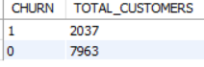

**Q5: Average Balance of Customers with Credit Cards**

SELECT CREDIT_CARD, AVG(BALANCE) AS AVERAGE_BALANCE

FROM CUST_DT

GROUP BY CREDIT_CARD;

Output:

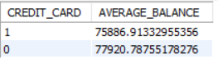

**Q6: List of Unique Countries**

SELECT DISTINCT(COUNTRY) FROM CUST_DT;

Output:

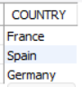

**Advanced Level**

**Q7: Percentage of Active Members Who Have Churned**

SELECT ACTIVE_MEMBER, AVG(CHURN) * 100 AS CHURN_PERCENTAGE

FROM CUST_DT

GROUP BY ACTIVE_MEMBER;

Output:

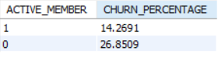

**Q8: Average Estimated Salary for Customers Who Have Churned**

SELECT AVG(ESTIMATED_SALARY) AS AVG_ESTIMATED_SALARY

FROM CUST_DT

WHERE CHURN = 1;

Output:



**Q9: Report on Number of Products Held by Each Customer and Their Churn Status**

SELECT CUSTOMER_ID, PRODUCTS_NUMBER, CHURN

FROM CUST_DT;

Output:

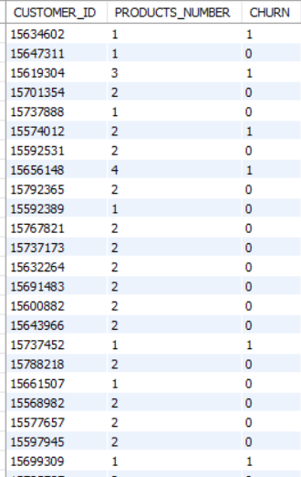

**Expert Level**

**Q10: Predict Churn Based on Customer Demographics Using a CASE Statement**

SELECT

CUSTOMER_ID,

CASE

WHEN AGE < 30 THEN 'YOUNG'

WHEN AGE BETWEEN 30 AND 50 THEN 'MIDDLE-AGED'

ELSE 'SENIOR'

END AS AGE_GROUP,

CHURN

FROM

CUST_DT;

Output:

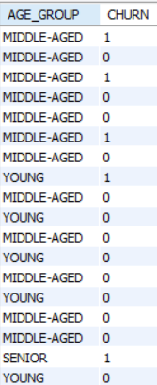

**Q11: Trends in Customer Balances Over Time for Churned Customers**

SELECT TENURE, AVG(BALANCE) AS AVERAGE_BALANCED_CHURNED

FROM CUST_DT

WHERE CHURN = 1

GROUP BY TENURE

ORDER BY TENURE;

Output:

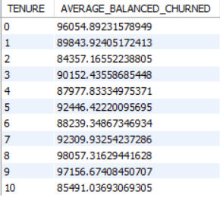

**Q12: Summary Report Grouping Customers by Country (Average Balance and Churn Rate)**

SELECT COUNTRY, AVG(BALANCE) AS AVERAGE_BALANCE, AVG(CHURN) AS CHURN_RATE

FROM CUST_DT

GROUP BY COUNTRY;

Output:

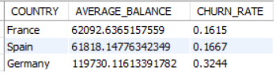

**Q13: Top 10% of Customers Based on Estimated Salary and Their Churn Status**

WITH SALARYRANKED AS (

SELECT *, NTILE(10) OVER (ORDER BY ESTIMATED_SALARY DESC) AS SALARY_DECILE

FROM CUST_DT

)

SELECT CUSTOMER_ID, ESTIMATED_SALARY, CHURN

FROM SALARYRANKED

WHERE SALARY_DECILE = 1;

Output:

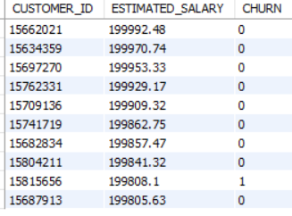

**Q14: Create a View with Tenure Categorized Into Ranges**

CREATE VIEW CUSTOMER_TENURE_VIEW AS

SELECT CUSTOMER_ID,

CASE

WHEN TENURE = 0 THEN 'NEW'

WHEN TENURE BETWEEN 1 AND 3 THEN '1-3 YEARS'

WHEN TENURE BETWEEN 4 AND 6 THEN '4-6 YEARS'

ELSE '7+ YEARS'

END AS TENURE_CATEGORY,

CREDIT_SCORE, COUNTRY, GENDER, AGE, BALANCE, PRODUCTS_NUMBER, CREDIT_CARD, ACTIVE_MEMBER, ESTIMATED_SALARY, CHURN

FROM CUST_DT;

SELECT * FROM CUSTOMER_TENURE_VIEW;

Output:

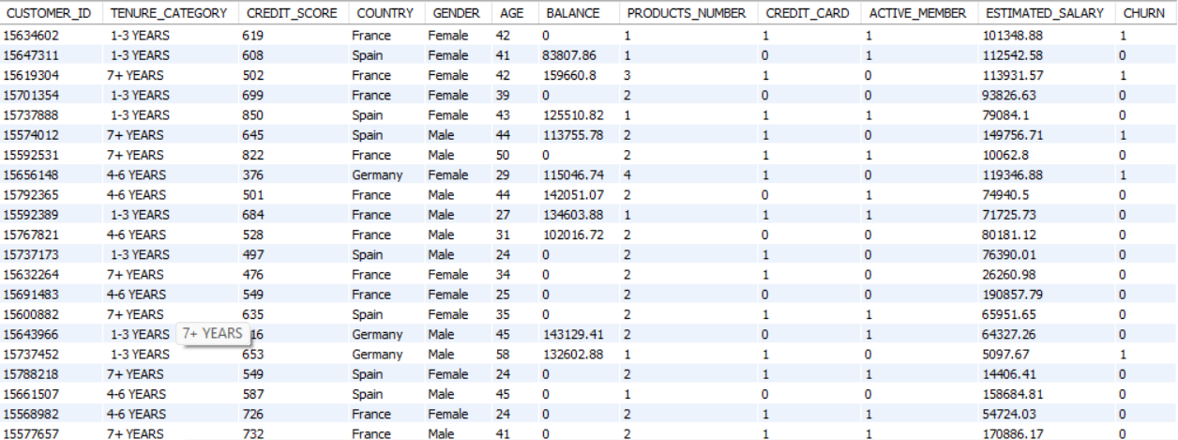

**Business Scenario Questions**

**Customer Segmentation**

**Characteristics of Customers Who Churn vs. Those Who Remain**

SELECT

AVG(AGE) AS AVG_AGE,

AVG(BALANCE) AS AVG_BALANCE,

COUNT(*) AS TOTAL_CUSTOMERS,

SUM(CASE WHEN CHURN = 1 THEN 1 ELSE 0 END) AS CHURNED_CUSTOMER,

SUM(CASE WHEN CHURN = 0 THEN 1 ELSE 0 END) AS RETAINED_CUSTOMER

FROM CUST_DT

GROUP BY CHURN;

Output:

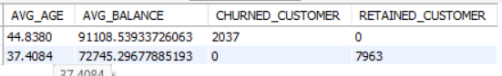

**Churn Prediction**

**Predict Which Customers Are Likely to Churn**

SELECT CUSTOMER_ID, COUNTRY, GENDER, AGE, BALANCE, CREDIT_SCORE, CHURN

FROM CUST_DT

WHERE CHURN = 1;

Output:

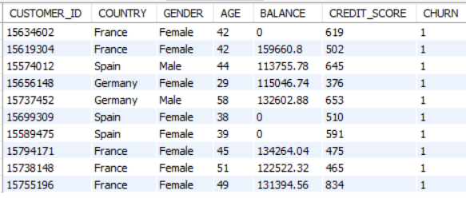

**Product Usage**

**Relation Between Number of Products and Likelihood of Churning**

SELECT

PRODUCTS_NUMBER, AVG(CHURN) AS AVG_CHURN_RATE

FROM CUST_DT

GROUP BY PRODUCTS_NUMBER;

Output:

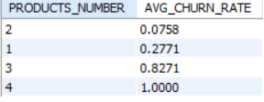

**Demographic Analysis**

**Demographic Factors Associated With Higher Churn Rates**

SELECT

COUNTRY,

GENDER,

AVG(AGE) AS AVG_AGE,

AVG(CHURN) AS HIGH_CHURN_RATES

FROM CUST_DT

GROUP BY COUNTRY, GENDER

ORDER BY HIGH_CHURN_RATES DESC;

Output:

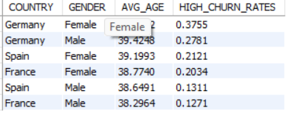

**Balance Impact**

**Correlation Between Higher Account Balance and Lower Churn Rates**

SELECT

CASE

WHEN BALANCE >= 125000 THEN 'HIGH BALANCE'

ELSE 'LOW BALANCE'

END AS BALANCE_CATEGORY,

AVG(CHURN) AS AVG_CHURN_RATE

FROM CUST_DT

GROUP BY BALANCE_CATEGORY;

Output:

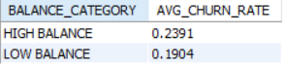

**Tenure Analysis**

**Relationship Between Tenure and Likelihood to Churn**

SELECT

TENURE, AVG(CHURN) AS AVG_CHURN_RATE

FROM CUST_DT

GROUP BY TENURE

ORDER BY TENURE;

Output:

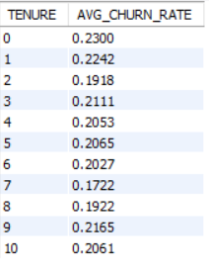

**Marketing Strategies**

**Targeted Marketing Strategies to Reduce Churn**

SELECT

COUNTRY, GENDER, AGE_GROUP, COUNT(*) AS POTENTIAL_TARGETS

FROM

(SELECT

GENDER, COUNTRY,

CASE

WHEN AGE BETWEEN 18 AND 30 THEN 'YOUNG'

WHEN AGE BETWEEN 30 AND 55 THEN 'MIDDLE_AGE'

ELSE 'SENIOR'

END AS AGE_GROUP

FROM CUST_DT

WHERE CHURN = 1) AS SUBQUERY

GROUP BY GENDER, COUNTRY, AGE_GROUP;

Output:

